**Project 1: Insights from Data(Malaria Deaths in Africa)**

**1.**

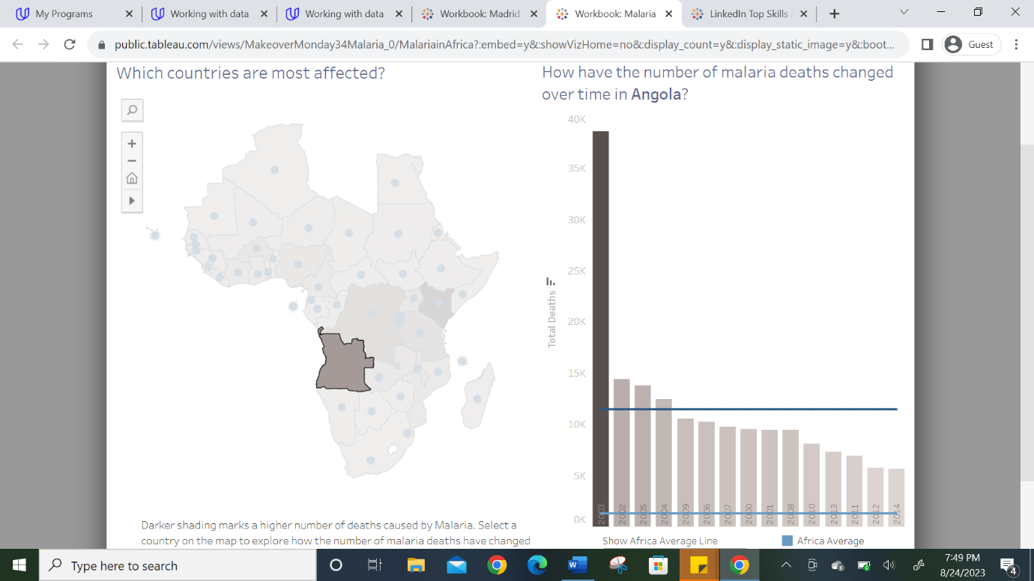

It was observed from the dashboard that before the year 2003, there were records of about 11,000 malaria deaths yearly in Angola. A sudden increase of about 40,000 malaria deaths in the year 2003 was observed before a great decline of about 65% afterward.

The image above was obtained when I selected Angola’s map on the main map of Africa as seen on the dashboard and it displayed the country’s chart of the total malaria deaths from the year 2000 to 2014.

**2.**

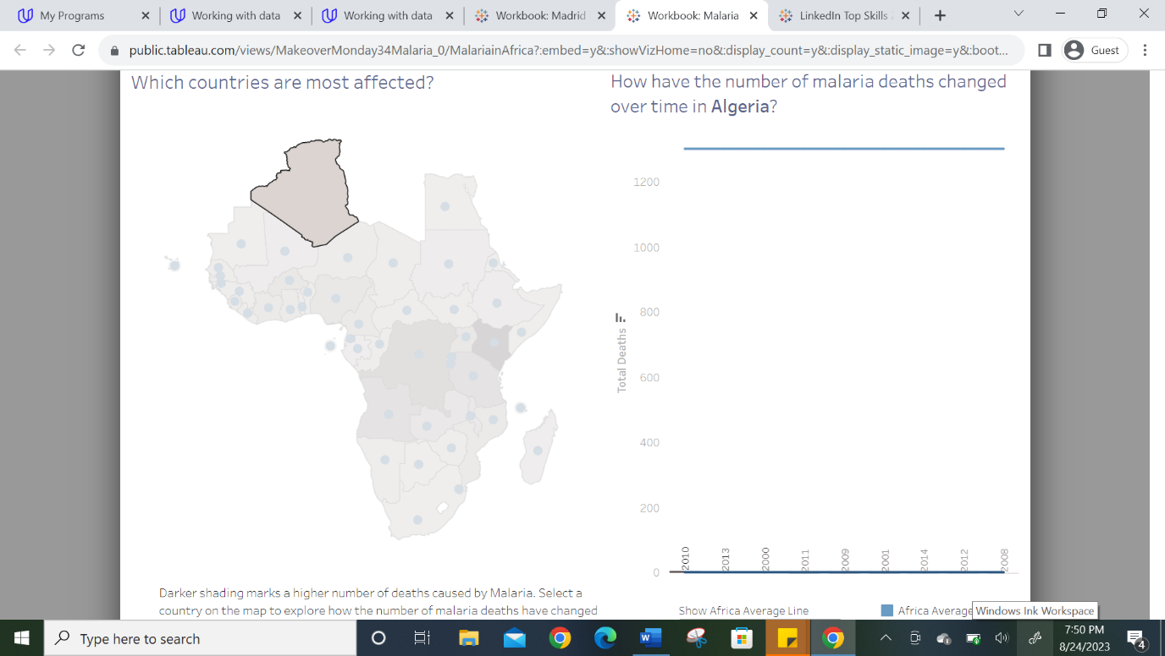

I tapped on Algeria on the Africa map displayed on the dashboard and it brought the country’s chart of the total malaria deaths from year 2000 to 2014. There was no change observed in the number of malaria deaths in Algeria over time because they only experienced 1 malaria death yearly.

**3.**

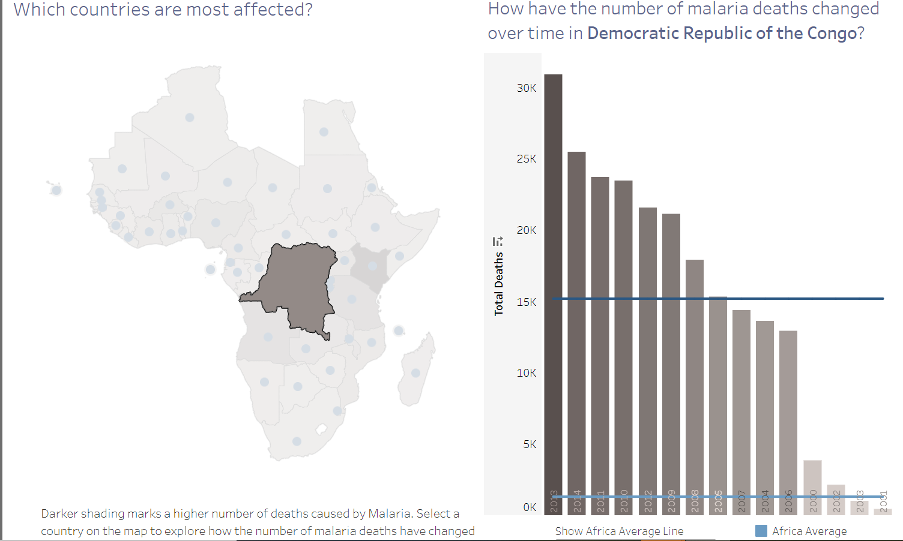

The number of malaria deaths in the Democratic Republic of the Congo was about 1,000 to 3,000 yearly before 2004. A steady increase of about 13,000 to 25,000 malaria deaths yearly was observed from year 2004 till 2014. I tapped on the Democratic Republic of the Congo on the Africa map on the dashboard and it displayed the chart of the total malaria deaths from the year 2000 to 2014.